St Lorcan’s Active
Week Quiz

Round 1- Soccer
- Who is the new manager of the Republic of Ireland?
- Which team are currently bottom of the Premier League?
- Which Premier League Club does Troy Parrot play for?
- Which SSE Airtricity team play their home games in Oriel Park?
- What kind of animal is featured on Leicester City’s badge?
- Which county does Shane Duffy hail from?

Round 2- GAA
- Who is the new manager of the Dublin Football team?
- Who did Dublin beat in the 2019 All-Ireland Football Final?
- Who won the 2018 All-Ireland Hurling Final?
- Which county did former hurler, Henry Shefflin play for?
- Which county does David Clifford play for?
- How many players play in the forward-line?

Round 3- Rugby
- Who is the captain of the Irish Rugby Team?
- What colour jerseys do Connaught wear?
- Who is the new manager of the Irish Rugby Team?
- Where was the 2019 Rugby World Cup held?
- Who won the 2019 World Cup?
- Who is Eoin Farrell?
Round 4- The Olympics
- How many rings are there on the Olympic Flag?

- 4
- 5
- 6
- 7

- The Olympic Games are held every-

- year
- 2 years
- 3 years
- 4 years

- The 2020 Olympics were due to take place this summer in –

- London
- Paris
- Tokyo
- Berlin
- In athletics, how many events are there in the pentathlon?

- 3
- 5
- 6
- 8
- How many metres long is an Olympic sized swimming pool?
- 25m
- 50m
- 60m
- 80m
- Which sport do the O’Donavan Brothers compete in? They won a silver at the 2016 Olympics in Rio.
- Tennis
- Badminton
- Rowing
- Table Tennis
Round 5- Name the Sports Star
1  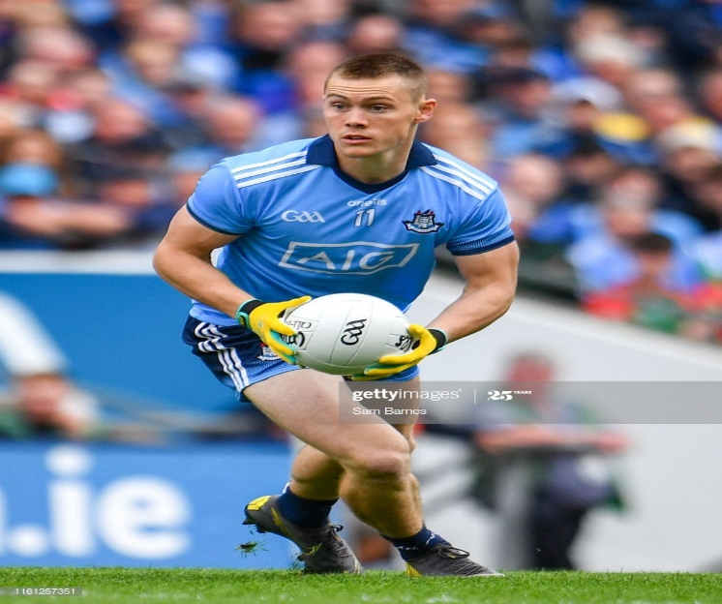 | 2  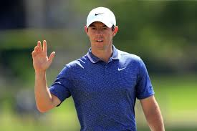
3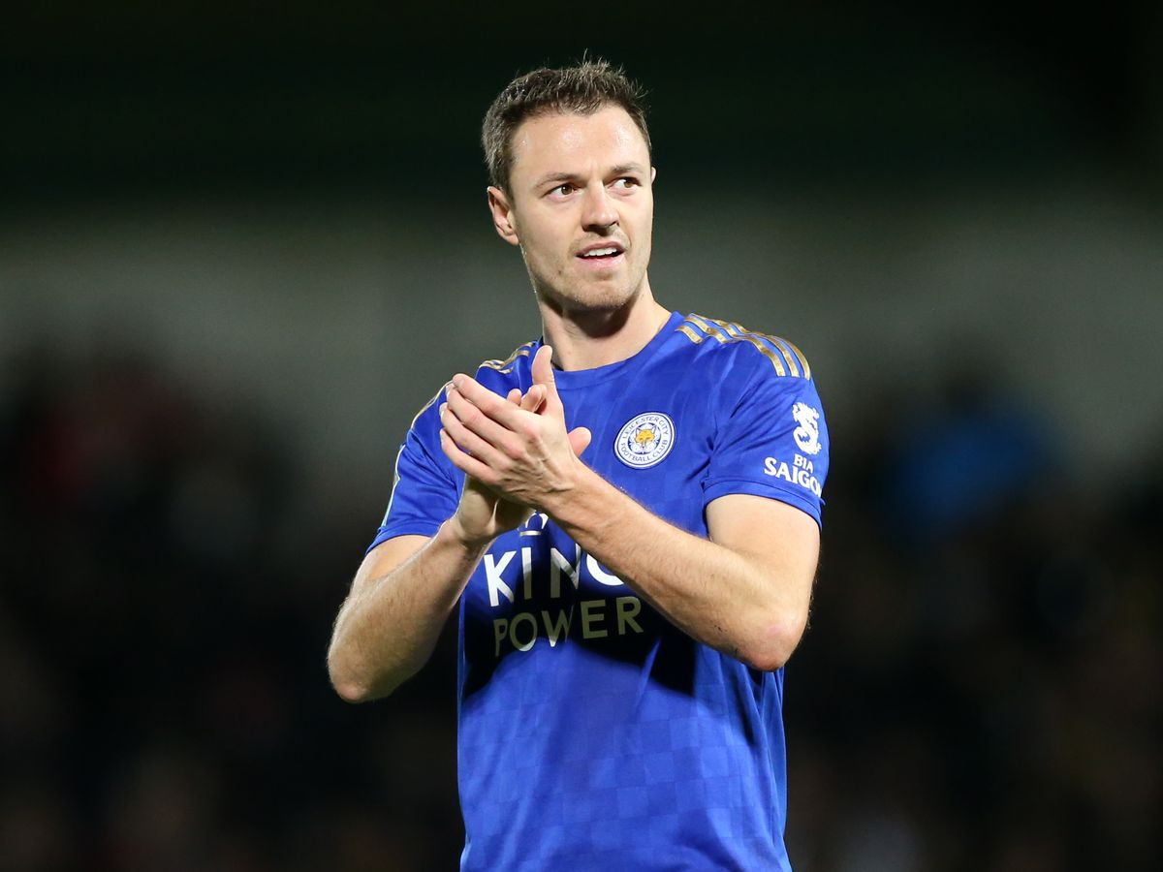 | 4  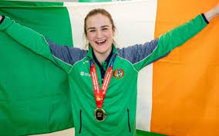
5  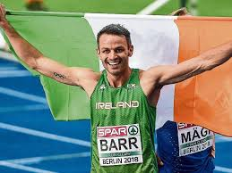 | 6  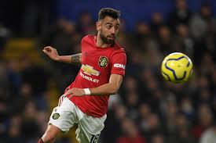

Round 6- St. Lorcan’s
- Who trains the Athletics Team?
- What colours are the St. Lorcan’s jerseys?
- What flag did we renew last year?
- What 2 events are typically held on the final day of Active Week?
- How many laps of the oval is equivalent to 1 Mile?
- Where do the Soccer Team play their home games?

Round 7- Mixed Bag
- Which sport does Shane Lowry play and compete in?
- Can you unscramble the following word to reveal a type of sport-
GMMIWISN
- Which sport involves a bat, a ball and wickets?
- Which chess piece holds the most value on a chess board?
- Can you unscramble the following word to reveal a type of sport-
GINKIS
- What is the name of the racket game played in a closed wall court with a rubber ball?

Answers
Round 1
- Stephen Kenny
- Norwich City
- Tottenham Hotspur
- Dundalk
- Fox
- Derry

Round 2
- Dessie Farrell
- Kerry
- Limerick
- Kilkenny
- Kerry
- 6

Round 3
- Johnny Sexton
- Green
- Andy Farrell
- Japan
- South Africa
- England captain and son of Ireland manager Andy Farrell

Round 4
- 5 rings
- 4 years
- Tokyo
- 5 events
- 50m
- Rowing

Round 5
- Con O’ Callaghan
- Rory McIlroy
- Jonny Evans
- Kellie Harrington
- Thomas Barr
- Bruno Fernades

Round 6
- Ms. McSorley, Ms. Fenton, Mr. Daly + Mr. Farrell
- Red + White
- The Active Flag
- The Fun Run and the Teachers V Pupils Match
- 5 Laps
- Mill Lane

Round 7
- Golf
- Swimming
- Cricket
- The Queen
- Skiing
- Squash

